# **Free Chlorine and Cyanuric Acid System Simulator (FCCAS) Deployment Instructions**

## Deployment prerequisites

* Cloud.gov access and specifically ***epa-rshiny*** organization deployment permissions.
* Cloud Foundry Command Line Interface (cf [CLI](https://docs.cloudfoundry.org/cf-cli/install-go-cli.html))
* A web browser with internet access

## Deployment steps

1. Download the latest FCCAS release from GitHub as a zipped file from: <https://github.com/USEPA/Free_Chlorine_and_Cyanuric_Acid_Simulator/archive/master.zip>
2. Unzip the FCCAS release file.
3. Using the command line, navigate to the unzipped FCCAS location. The contents of the folder should look like:

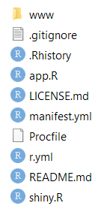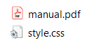

1. Use the cf CLI to log in to Cloud.gov and to the ***epa-rshiny*** organization and to the ***fccas-prod*** space.
   * + - cf login -a api.fr.cloud.gov --sso
       - cf target -o epa-rshiny -s fccas-prod
2. Deploy the application to Cloud.gov using the CLI.
   * + - cf push
3. Verify application deployment using the CLI.
   * + - cf app fccas
4. Notify the customer that the application has been deployed.